Table 1: Comparison between forward feedback data input and back error propagation [10-12].
Feedforward data input (FFDI)
- All the layers feed into one another from the input till output in the forward direction.
- By default, the architecture of FFDI assumes that all the nodes in a given layer are linked to those in the next layer.
- Therefore, the architecture of FFDI is almost fully defined except the loss function that is augmented in the output layer.
- The perceptron algorithm uses the perceptron criterion, this is not the only choice.
Figure 1. Feedforward data input schematic diagram.

Backward Error Propagation (BEP)
- It utilizes the chain rules defined mathematically to calculate gradients for each layer iteratively.
- It the most commonly used network for various applications.
- It is classified into two main phases: (a) Forward phase and (b) Backward phase.
- The forward phase is used to calculate the outputs and derivatives at different local nodes.
- The backward phase is used to collect the products of these local values all over the paths from the starting node till the output.

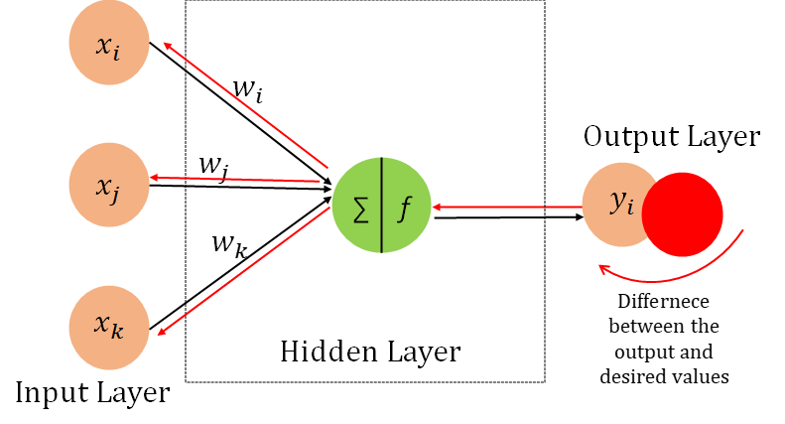
Figure 2: Backward Error Propagation Network schematic diagram.

