Table 8: Base line of electric aircraft.

Aircraft | Dimensional parameters |  | Performance parameters
Pipistrel Alpha Electro G2 [48]  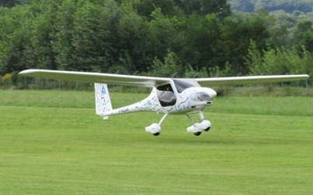 | Span Wing: 10.5 m  Length: 6.5 m  Height: 2.05 m  Aspect Ratio: 11.8 | Fuselage: Side-by-side, cabin.  Wing: Rectangular, high wing, monoplane, fixed wing.  Tail: T-tail, aft tail.  Engine: tractor (single-engine) propeller-driven  Landing gear: Tricycle | Max takeoff weight: 550 kg  Payload weight: 182 kg  Stall Speed: 70.3 km/h  Cruise Speed: 157.42 km/h | Max Speed: 250 km/h  Engine: Pipistrel PEM 60MVLC; 60 kW power  Endurance: 1 hour  Cruise Range: 138.9 km
Liaoning Ruixiang RX1E [49]  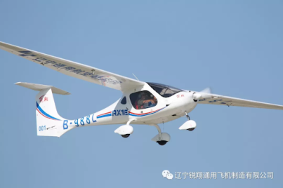 | Span Wing: 14.5 m  Length: 6.61 m  Height: 2.45 m  Aspect Ratio: | Fuselage: Side-by-side, cabin.  Wing: Rectangular, Tapered, high wing, monoplane, fixed wing.  Tail: T-tail, aft tail.  Engine: tractor (single-engine) propeller-driven  Landing gear: Tricycle | Max takeoff weight: 500 kg  Payload weight: 162 kg  Stall Speed: 73 km/h  Cruise Speed: 120 km/h | Max Speed: 160 km/h  Engine: A37K154; 30 kW power  Endurance: 1 hour  Cruise Range:
Bristell H-55 [50]  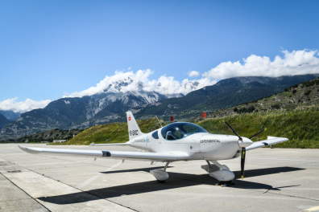 | Span Wing: 8.13 m  Length: 6.45 m  Height: 2.28 m  Aspect Ratio: | Fuselage: Side-by-side, cockpit.  Wing: Rectangular, low wing, monoplane, fixed wing.  Tail: Conventional, aft tail.  Engine: tractor (single-engine) propeller-driven  Landing gear: Tricycle | Max takeoff weight: 850 kg  Payload weight: 200 kg  Stall Speed:  Cruise Speed: | Max Speed:  Engine: 90 kW power  Endurance: 1.5 hours  Cruise Range:
Bye Aerospace eFlyer 2 [51]  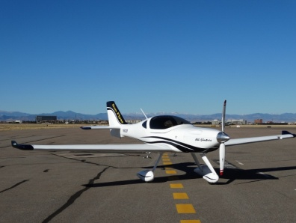 | Span Wing: 11.58 m  Length:  Height:  Aspect Ratio: | Fuselage: Side-by-side, cockpit.  Wing: Rectangular, low wing, monoplane, fixed wing.  Tail: Conventional, aft tail.  Engine: tractor (single-engine) propeller-driven  Landing gear: Tricycle | Max takeoff weight: 862 kg  Payload weight: 200 kg  Stall Speed:  Cruise Speed: | Max Speed: 250 km/h  Engine: Siemens SP70D; 90 kW power  Endurance: 3.5 hours  Cruise Range:
Siemens Magnus eFusion [52]  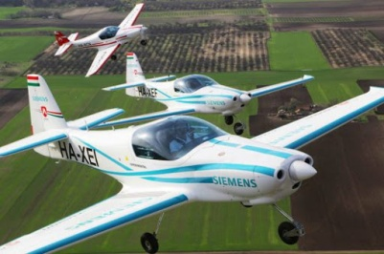 | Span Wing: 8.3 m  Length: 6.62 m  Height: 2.4 m  Aspect Ratio: | Fuselage: Side-by-side, cockpit.  Wing: Tapered, low wing, monoplane, fixed wing.  Tail: Conventional, aft tail.  Engine: tractor (single-engine) propeller-driven  Landing gear: Tricycle | Max takeoff weight: 600 kg  Payload weight: 190 kg  Stall Speed: 64.8 km/h  Cruise Speed: 185 km/h | Max Speed: 313 km/h  Engine: Siemens SP55D; 60 kW power  Endurance: 1 hour  Cruise Range:
Yuneec E 340 [53]  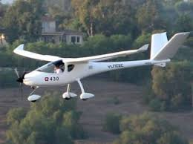 | Span Wing: 13.8 m  Length: 6.98 m  Height:  Aspect Ratio: | Fuselage: Side-by-side, cabin.  Wing: Tapered, rectangular, high wing, monoplane, fixed wing.  Tail: V-tail, aft tail.  Engine: tractor (single-engine) propeller-driven  Landing gear: Tricycle | Max takeoff weight: 470 kg  Payload weight: 177 kg  Stall Speed: 70 km/h  Cruise Speed: 96.5 km/h | Max Speed: 152.88 km/h  Engine: Yuneec Power Drive 40; 40 kW power  Endurance: 2.5 hours  Cruise Range: 227 km
Diamond DA-36 E-Star [54]  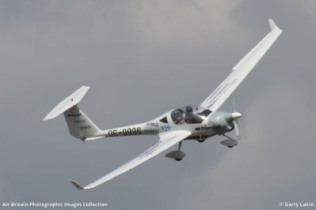 | Span Wing: 16 m  Length: 7.1 m  Height: 1.7 m  Aspect Ratio: | Fuselage: Side-by-side, cockpit.  Wing: Tapered, low wing, monoplane, fixed wing.  Tail: T-tail, aft tail.  Engine: tractor (single-engine) propeller-driven  Landing gear: Tricycle | Max takeoff weight: 800 kg  Payload weight:  Stall Speed:  Cruise Speed: | Max Speed:  Engine: Siemens; 70 kW power  Endurance:  Cruise Range:
Extra 300 LE [55]  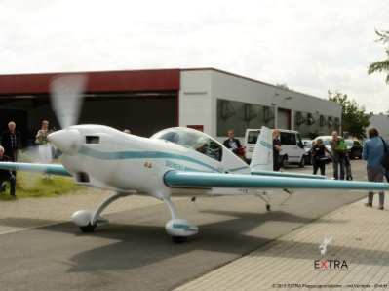 | Span Wing: 8 m  Length: 7.5 m  Height: 2.6 m  Aspect Ratio: | Fuselage: Tandem, cockpit.  Wing: Tapered, low wing, monoplane, fixed wing.  Tail: Conventional, aft tail.  Engine: tractor (single-engine) propeller-driven  Landing gear: Tail gear | Max takeoff weight: 820 kg  Payload weight: 200 kg  Stall Speed: 101.86 km/h  Cruise Speed: | Max Speed: 337.5 km/h  Engine: Siemens SP260D; 260 kW power  Endurance: 20 minutes at max power  Cruise Range:

